Third Trial Short Final Summary Report
This short report summarises the final results of the Third Trial. It brings together the RGB evidence from visible emergence and green-cover analysis with the multispectral evidence from relative NDVI and NDRE. The aim is to give a clear, readable summary of what the trial showed and how the final outputs should be used.
The report is based on the completed workflow outputs from Scripts 04 to 10. It does not recalculate the image-processing results. Instead, it reads the final synthesis tables and uses them to prepare a concise written interpretation.

1. Trial overview
The Third Trial was designed to compare seedling emergence and growth under different microbial, environmental, heat and moisture conditions. Each tray contained a 7 × 10 grid, giving 70 cells per tray. Twelve trays were included, so a complete observation day contained 840 cell-level positions across all trays.
Seeds were planted on Day 0, 27 June 2026. Image collection started on Day 1, 29 June 2026, and continued through Day 7, 7 July 2026. Images were not taken on 5 and 6 July because most seeds were already visibly germinated, and the final image set was taken later to support growth-rate comparison.
Trial Day | Date Or Note
Day 0 | 27/06/2026 — seeds planted
Day 1 | 29/06/2026 — first image set
Day 2 | 30/06/2026
Day 3 | 01/07/2026
Day 4 | 02/07/2026
Day 5 | 03/07/2026
Day 6 | 04/07/2026
Day 7 | 07/07/2026 — final image set

2. Treatment structure
The tray labels used M for Microbes, N/M for No Microbes, In for Inside greenhouse, and Out for Outside in the open. Ideal trays stayed fully inside or fully outside. Heat trays were moved during the trial, while Moisture trays followed a watering schedule.
Tray | Microbe Status | Treatment | Environment
Tray 1 | No Microbes | Ideal | Inside
Tray 2 | No Microbes | Ideal | Outside
Tray 3 | No Microbes | Moisture | Outside
Tray 4 | No Microbes | Heat | Dynamic Heat
Tray 5 | Microbes | Moisture | Inside
Tray 6 | Microbes | Heat | Dynamic Heat
Tray 7 | Microbes | Ideal | Outside
Tray 8 | Microbes | Heat | Dynamic Heat
Tray 9 | Microbes | Ideal | Inside
Tray 10 | Microbes | Moisture | Outside
Tray 11 | No Microbes | Heat | Dynamic Heat
Tray 12 | No Microbes | Moisture | Inside
For the Heat treatment, the heat-labelled trays were inside at planting, moved outside on Day 3, stayed outside for Days 4 and 5, and were returned inside on Day 6. For the Moisture treatment, trays were watered on Day 0, Day 3 and Day 6, with drying intervals in between.

3. Workflow summary
- Script 04 detected visible emergence and RGB green-cover evidence from the cropped RGB images.
- Script 05 compared RGB emergence, green-cover and growth-rate outcomes across treatments.
- Script 06 produced independent multispectral 70-cell grids directly from the MS_NIR images.
- Script 07 calculated relative image-derived NDVI and NDRE from the original multispectral TIFF bands.
- Script 08 compared multispectral treatment outcomes and created observed and adjusted Day 7 summaries.
- Script 09 combined RGB and multispectral evidence into a final tray-level synthesis.
- Script 10 collected the key figures, reports, tables and evidence files into one final package.

4. Key findings
Topic | Finding | Value | Source Table
Top tray | Tray 8 had the highest final combined RGB + MS score. | 81.34 | final_combined_tray_synthesis.csv
Microbes vs No Microbes | Microbes had the higher mean combined RGB + MS score. | 62.53 | final_group_synthesis.csv
Treatment comparison | Heat had the highest mean combined RGB + MS score among the treatment types. | 68.20 | final_group_synthesis.csv
Inside vs Outside — Ideal | Outside trays performed better on the combined RGB + MS score. | -3.99 | final_inside_outside_synthesis.csv
Inside vs Outside — Moisture | Inside trays performed better on the combined RGB + MS score. | 27.16 | final_inside_outside_synthesis.csv
Day 7 adjusted scenario | Observed Day 7 values were preserved, while likely bug-eaten cells were kept as a separate adjusted scenario. | 396 | final_combined_tray_synthesis.csv
Output package | The final package collected Word reports, Excel workbooks, CSV tables, charts and evidence files from Scripts 04–09. | 114 | third_trial_package_manifest.csv

5. RGB visible emergence and green-cover evidence
The RGB workflow measured what was directly visible in the cropped colour images. This included visible emergence, green-cover development and adjusted Day 7 green-cover handling for cells where seedlings had appeared earlier but were missing later.
The strongest RGB evidence was recorded by Tray 1, with a normalised RGB score of 97.58. This score summarises the available visible emergence and green-cover indicators.

6. Multispectral NDVI and NDRE evidence
The multispectral workflow used the original MS_G, MS_R, MS_RE and MS_NIR TIFF bands. The main vegetation indices were relative NDVI and relative NDRE. These should be described as image-derived relative indices unless calibrated reflectance data are available.
The strongest multispectral evidence was recorded by Tray 8, with a normalised MS score of 86.87. The MS score summarises the available NDVI and NDRE-based indicators.

7. Final combined RGB + MS interpretation
The highest final combined RGB + MS score was recorded by Tray 8 (Microbes | Heat | Dynamic Heat). Its combined score was 81.34.
Tray 8 showed strong overall performance. The evidence pattern was classified as: RGB and MS broadly agree.
The combined score should be treated as a descriptive synthesis. It helps rank trays and summarise the overall pattern, but it is not a formal statistical test.
Combined Rank | Tray | Microbe Status | Treatment | Environment Group | Combined Rgb Ms Score | Rgb Score Normalised | Ms Score Normalised | Evidence Agreement | Total Day7 Adjusted Cells
1 | Tray 8 | Microbes | Heat | Dynamic Heat | 81.342 | 75.812 | 86.872 | RGB and MS broadly agree | 16
2 | Tray 5 | Microbes | Moisture | Inside | 72.893 | 81.613 | 64.173 | RGB stronger than MS | 90
3 | Tray 6 | Microbes | Heat | Dynamic Heat | 71.888 | 73.378 | 70.399 | RGB and MS broadly agree | 0
4 | Tray 7 | Microbes | Ideal | Outside | 64.911 | 55.289 | 74.532 | MS stronger than RGB | 4
5 | Tray 12 | No Microbes | Moisture | Inside | 62.005 | 66.785 | 57.225 | RGB and MS broadly agree | 18
6 | Tray 11 | No Microbes | Heat | Dynamic Heat | 61.451 | 56.962 | 65.940 | RGB and MS broadly agree | 36
7 | Tray 4 | No Microbes | Heat | Dynamic Heat | 58.123 | 66.118 | 50.128 | RGB stronger than MS | 36
8 | Tray 1 | No Microbes | Ideal | Inside | 56.798 | 97.584 | 16.012 | RGB stronger than MS | 120
9 | Tray 10 | Microbes | Moisture | Outside | 47.724 | 18.909 | 76.539 | MS stronger than RGB | 0
10 | Tray 9 | Microbes | Ideal | Inside | 36.424 | 35.112 | 37.735 | RGB and MS broadly agree | 72
11 | Tray 2 | No Microbes | Ideal | Outside | 36.294 | 26.153 | 46.434 | MS stronger than RGB | 0
12 | Tray 3 | No Microbes | Moisture | Outside | 32.861 | 30.500 | 35.222 | RGB and MS broadly agree | 4
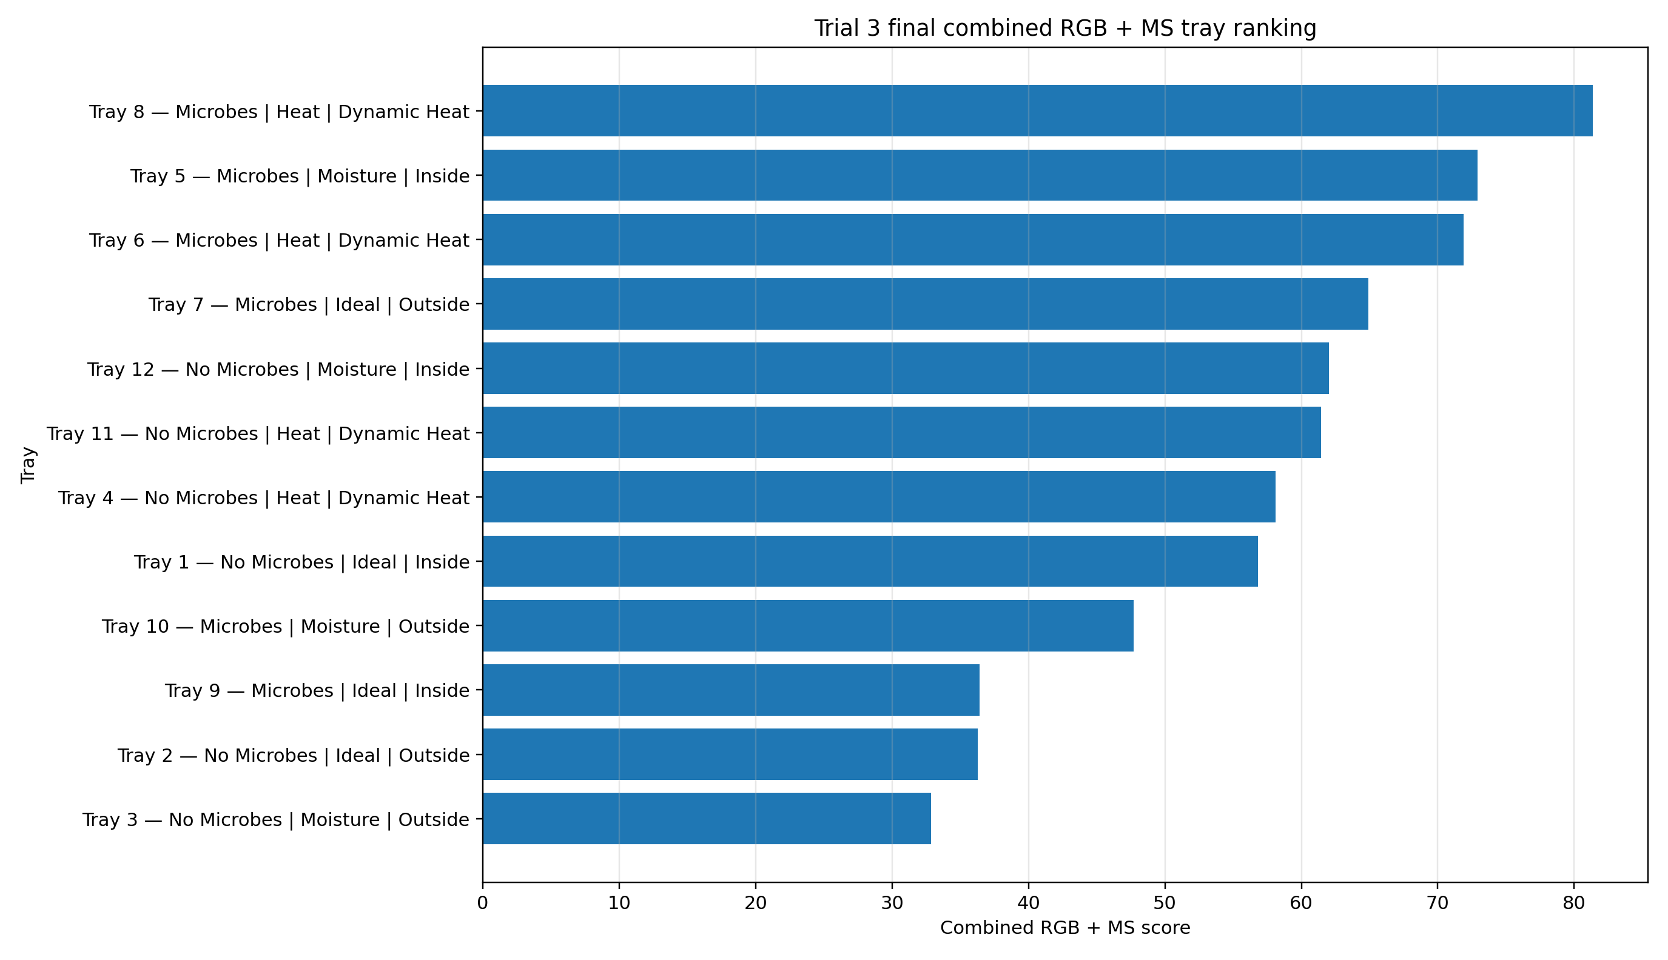
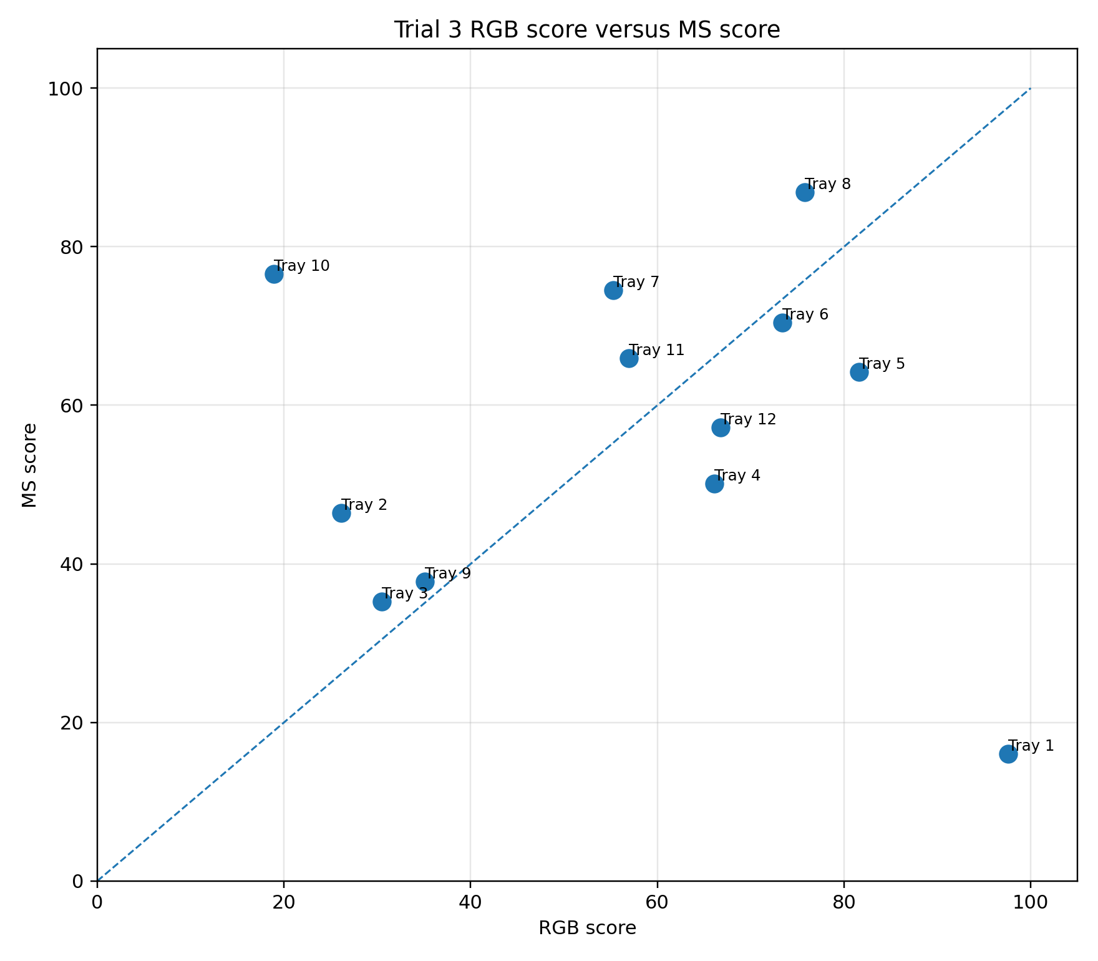

8. Microbes vs No Microbes
In the Microbes vs No Microbes comparison, Microbes had the higher mean combined score (62.53).
Group | Tray Count | Trays | Mean Combined Rgb Ms Score | Mean Rgb Score | Mean Ms Score | Best Tray In Group
Microbes | 6 | Tray 5, Tray 6, Tray 7, Tray 8, Tray 9, Tray 10 | 62.530 | 56.686 | 68.375 | Tray 8
No Microbes | 6 | Tray 1, Tray 2, Tray 3, Tray 4, Tray 11, Tray 12 | 51.255 | 57.350 | 45.160 | Tray 12
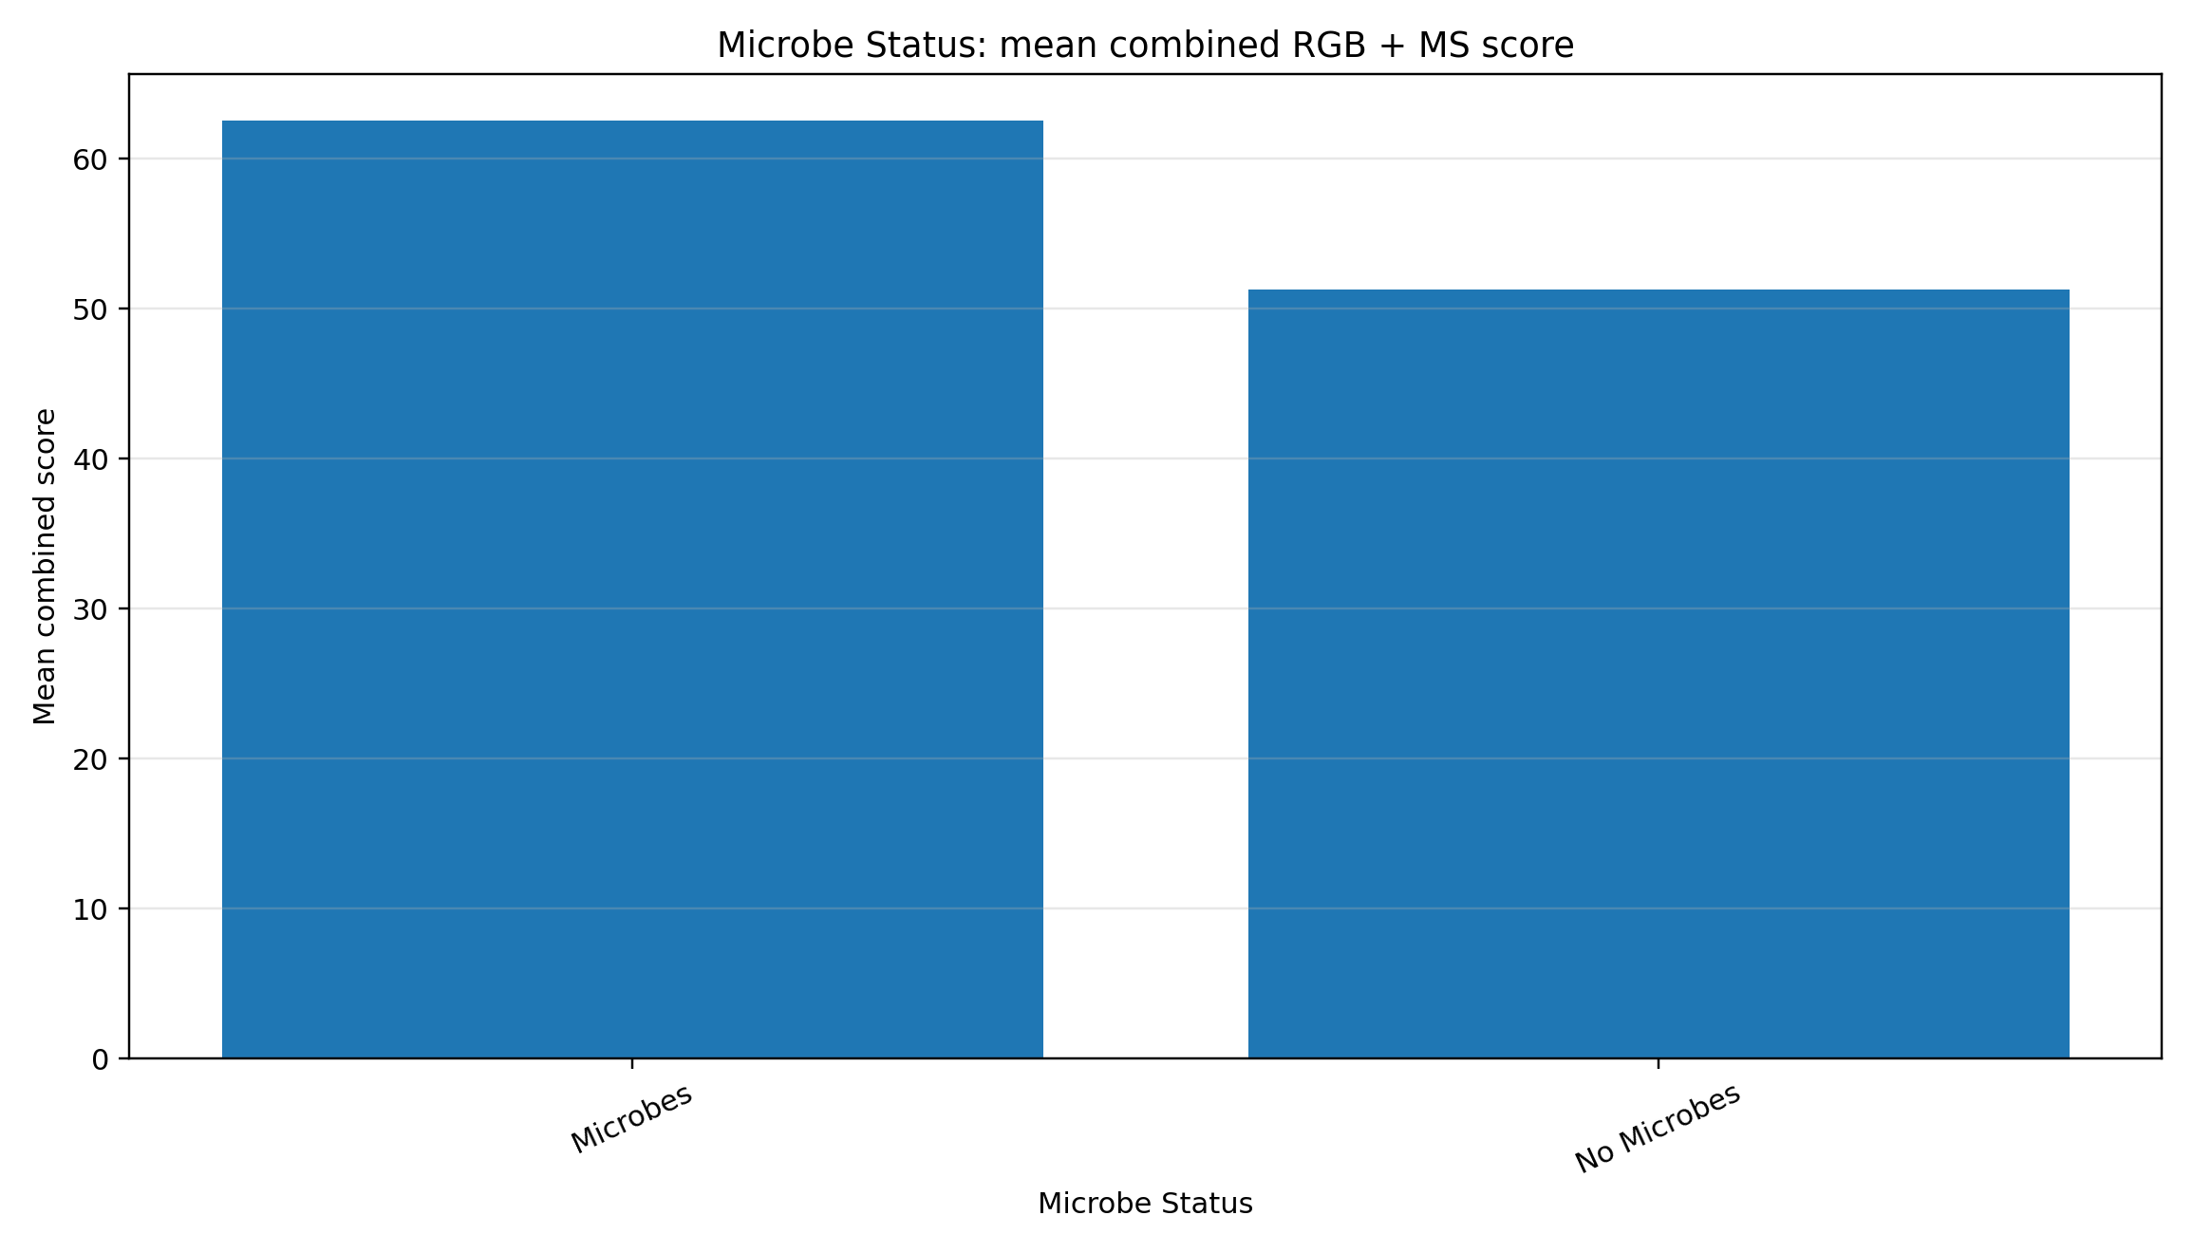

9. Ideal vs Heat vs Moisture
Across the three treatment types, Heat had the highest mean combined score (68.20).
Group | Tray Count | Trays | Mean Combined Rgb Ms Score | Mean Rgb Score | Mean Ms Score | Best Tray In Group
Heat | 4 | Tray 4, Tray 6, Tray 8, Tray 11 | 68.201 | 68.067 | 68.335 | Tray 8
Moisture | 4 | Tray 3, Tray 5, Tray 10, Tray 12 | 53.871 | 49.452 | 58.290 | Tray 5
Ideal | 4 | Tray 1, Tray 2, Tray 7, Tray 9 | 48.606 | 53.534 | 43.678 | Tray 7
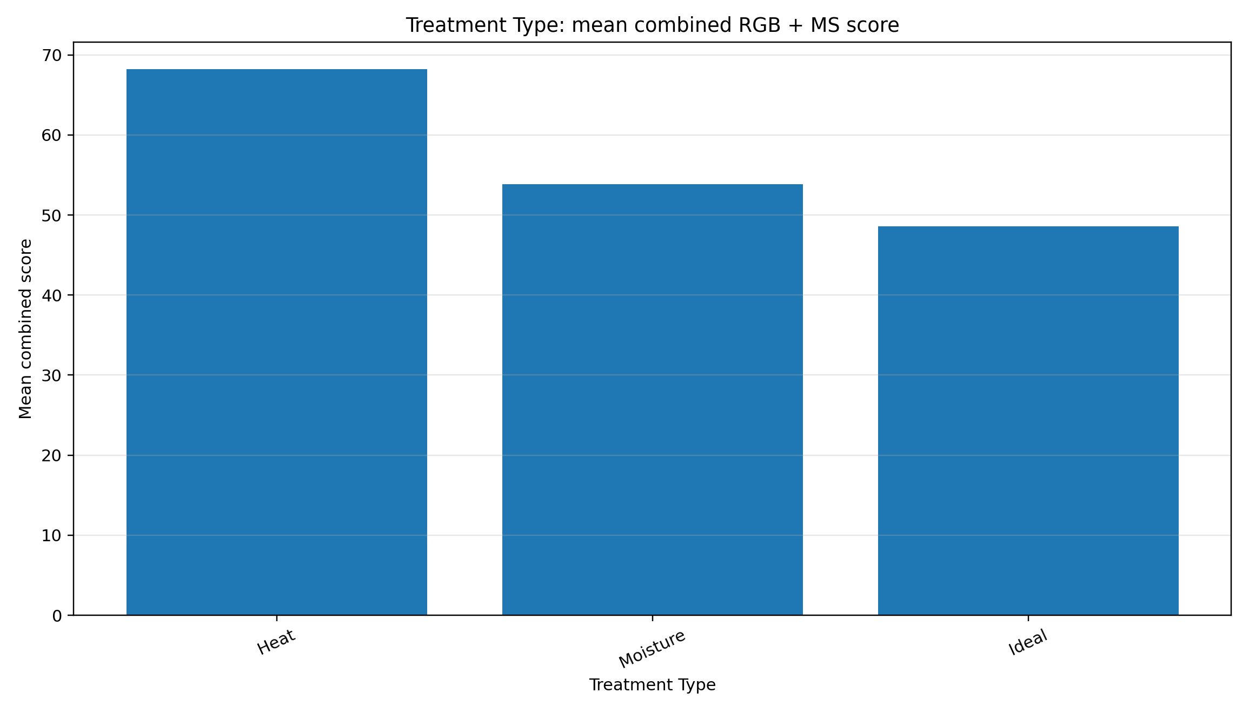

10. Inside vs Outside for Ideal and Moisture trays
The Inside vs Outside comparison was limited to Ideal and Moisture trays, because those trays had fixed environmental placement. Heat trays were not included in the direct fixed-environment comparison because they were moved between inside and outside during the trial.
Treatment | Inside Trays | Outside Trays | Inside Mean Combined Score | Outside Mean Combined Score | Inside Minus Outside Combined Score | Inside Mean Rgb Score | Outside Mean Rgb Score | Inside Mean Ms Score | Outside Mean Ms Score | Interpretation
Ideal | Tray 1, Tray 9 | Tray 2, Tray 7 | 46.611 | 50.602 | -3.991 | 66.348 | 40.721 | 26.873 | 60.483 | Outside trays performed better on the combined RGB + MS score.
Moisture | Tray 5, Tray 12 | Tray 3, Tray 10 | 67.449 | 40.292 | 27.157 | 74.199 | 24.704 | 60.699 | 55.880 | Inside trays performed better on the combined RGB + MS score.
For Ideal, the Inside-minus-Outside combined score difference was -3.99. Outside trays performed better on the combined RGB + MS score.
For Moisture, the Inside-minus-Outside combined score difference was 27.16. Inside trays performed better on the combined RGB + MS score.
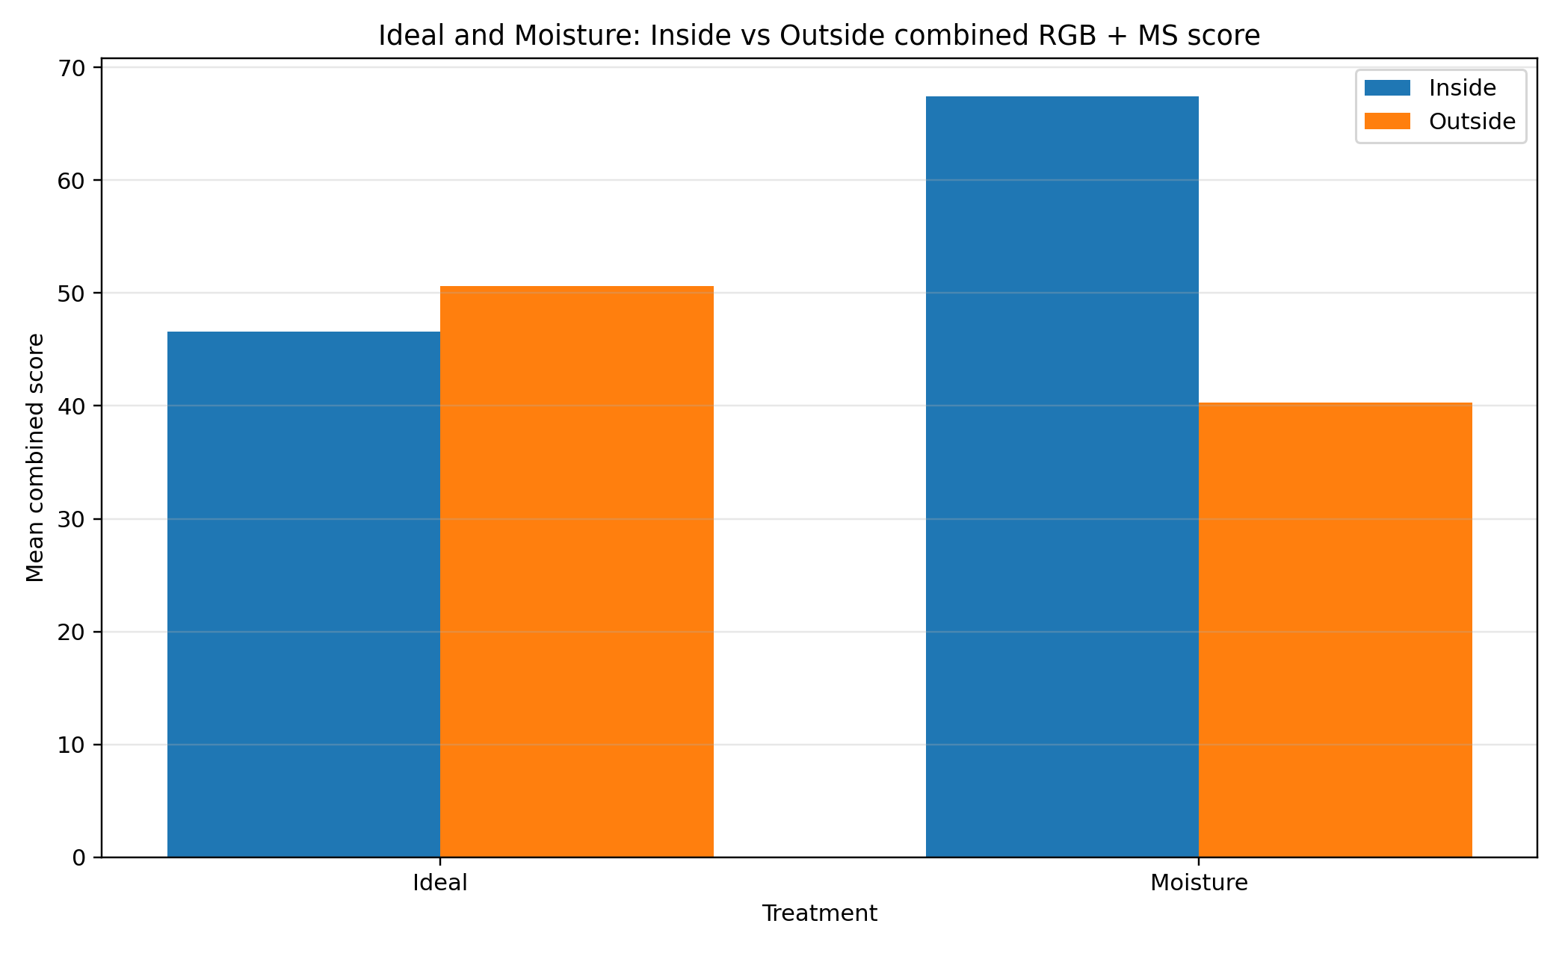

11. Heat and Moisture treatment response
Heat treatment was interpreted by movement phase rather than fixed environment. The trays were inside at baseline, moved outside during the heat-exposure period, and returned inside before the final image set. This means the Heat treatment should be read as a dynamic stress-and-recovery condition, not a simple Inside or Outside comparison.
Moisture treatment was interpreted around the watering schedule. Moisture trays were watered on Day 0, Day 3 and Day 6, with drying intervals between watering events. The fixed Inside/Outside comparison for Moisture trays is therefore useful, but it should still be interpreted alongside the watering timing.

12. Day 7 observed vs adjusted handling
The workflow recorded 396 total adjusted Day 7 cell records across the RGB and MS outputs. These adjusted values are not direct observations. They represent a separate scenario for cells where seedlings had appeared earlier but were missing on Day 7, which was treated as possible bug damage.
This separation is important. The observed Day 7 image values remain the main record of what was visible in the final images. The adjusted values are included only to support a fairer growth-rate comparison where plants may have been eaten after earlier growth.
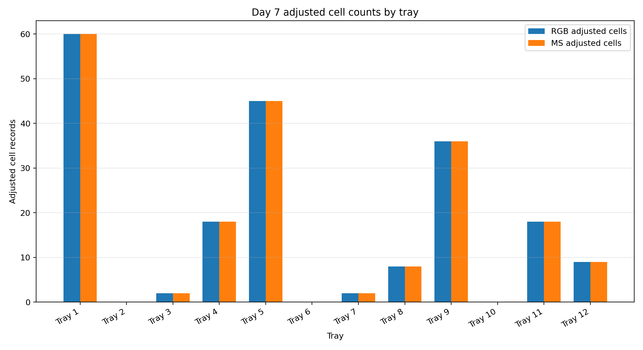

13. Limitations
- RGB and multispectral results measure related but different evidence. RGB measures visible green cover and emergence, while MS measures image-derived vegetation indices.
- NDVI and NDRE should be reported as relative image-derived indices unless reflectance calibration is confirmed.
- Soil, shadows, moisture, exposure, band alignment and polygon placement can affect MS values.
- The Day 7 adjusted values are estimated scenario values, not direct final-image observations.
- The final combined RGB + MS score is descriptive and should not be treated as a formal statistical significance test.
- The number of biological replicates per treatment group is limited, so group-level differences should be interpreted cautiously.

14. Output package guide
The main completed evidence package is the Script 10 final package. It contains the Word reports, Excel workbooks, CSV tables, charts and selected overlays from the Trial 3 workflow.
Final package ZIP: C:\Users\tshib\OneDrive\Desktop\Internship\outputs\Third trial\10_Final_Figure_Report_Package\Third_Trial_Final_Figure_Report_Package.zip
The package manifest lists 114 copied output files.
Source | Exists | Used | Notes
RGB tray growth metrics | True | Yes | Main RGB tray-level input.
RGB group growth metrics | True | Reference only | Group metrics are recomputed in this synthesis for consistency.
RGB Inside vs Outside comparison | True | Reference only | Inside/Outside comparison is recomputed from tray-level data.
RGB possible bug-eaten cells | True | Indirect | Already incorporated into Script 05 RGB adjusted values.
MS tray growth metrics | True | Yes | Main MS tray-level input.
MS group growth metrics | True | Reference only | Group metrics are recomputed in this synthesis for consistency.
MS Inside vs Outside comparison | True | Reference only | Inside/Outside comparison is recomputed from tray-level data.
MS possible bug-eaten adjusted cells | True | Indirect | Already incorporated into Script 08 MS adjusted values.

15. Main files created by this script
third_trial_short_final_summary_report.docx: The short final Word report for the Third Trial.
third_trial_summary_key_findings.csv: A compact table of the main findings used in this report.
third_trial_summary_report_settings.json: A settings file recording the input and output locations for this summary step.

